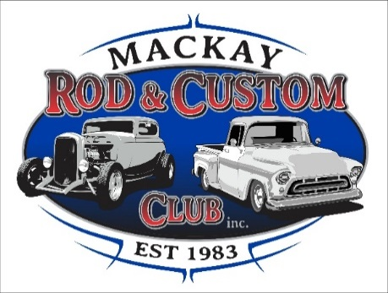

**OPENED:**

Sunday 6th March at the clubhouse.

Meeting opened 10:20am

**APOLOGIES:**

Norm Cameron, Ed Grima, Laurie Danastas, Martin De Thomasis Courtney Nipperess.

**1st MEETING:**

Grant Messer, Dennis Rose.

**2nd MEETING:**

Chris Schriha, Mark Camilleri, John Lawton.

**3rd MEETING:**

Dave McNicol, Carl Leeson, Marty Grogan.

MINUTES of previous meeting held on 6th March was approved by Tony Camilleri and seconded by Dave Bugeja.

**TREASURER’S REPORT:**

Read out by Sue Nipperess. Bank balance currently sits at $99894.46. Ongoing expenses are monthly rent payments with a tenant income of $200 per month. Treasurer’s report was seconded by Warren Smith.

**CORRESPONDENCE:**

Coffs Harbour Festival of Motorsport has emailed an event running Nov 5 to Nov 27. Email with details can be passed on to interested parties.

**GENERAL BUSINESS:**

Tim has stood down voluntarily as VP. Troy Billington nominated in his place. No further nominations.

Membership cards to be chased up. In the meantime, Autobarn will accept old cards.

Next meeting we are doing a run. Meeting to begin at 10am.

Members only facebook group will be made. There will be a public page remain.

Club members cannot take people for runs and be paid for it. Specific insurances are required to do this.

Trish Bezzina is a life member.

**NEXT MEETING:**

April 3rd

Meeting closed at 10:35am.

Thank you all for your attendance.